Sun protection for students and staff

Sun protection strategies

Summer is just around the corner
With Australia having one of the highest rates of skin cancer in the world, it is timely to remind students and staff to protect themselves from skin cancer.
In NSW UV conditions are ‘very high’ or ‘extreme’ throughout summer. During daylight saving, it’s best to seek shade where possible between 11am and 3pm.

Enhancing current practice
In addition to successful sun protection strategies already operating in NSW public schools, schools may wish to consider:
          - Increasing awareness of UV by embedding the free SunSmart UV Alert onto their school’s website. This widget can be downloaded at: http://www.sunsmart.com.au/uv-sun-protection/uv/uv-widget
The widget shows the daily sun protection times for locations throughout NSW. Sun protection measures are recommended when the UV Index is 3 and above. It is important to remind staff and students that you can still get burnt on cool or cloudy days – so think UV, not heat.
          - Including the following image in school newsletters (and other communication tools such as the school website) during daylight saving months (and especially during summer) to actively promote sun protection.

The image can be copied and pasted directly from this factsheet.
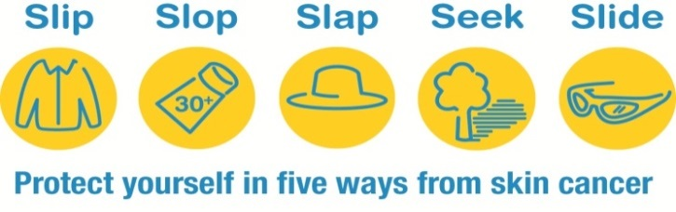
          - Encouraging staff to:
  - promote sun smart behaviour by modelling sun protection strategies (Slip, Slop, Slap, Seek, Slide)
  - incorporate age appropriate activities into classroom practice during daylight saving months
Further information can be found at:
- NSW Department of Education: https://education.nsw.gov.au/student-wellbeing/health-and-physical-care/sun-safety
- Cancer Institute NSW: https://www.cancerinstitute.org.au/how-we-help/cancer-prevention/skin-cancer-prevention
- Cancer Council NSW: https://www.cancercouncil.com.au/cancer-prevention/sun-protection/
For more information contact:
Louise Carey - Health and Wellbeing team
louise.carey9@det.nsw.edu.au

Cancer Council SunSmart team on 9334 1761
sunsmart schools@nswcc.org.au

